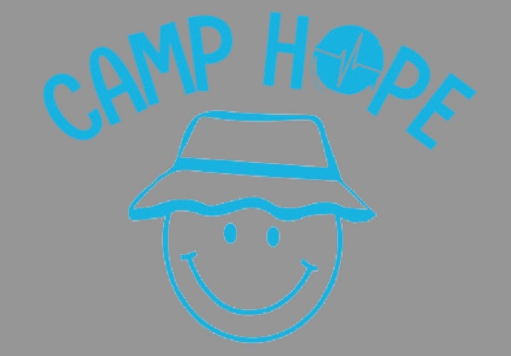

**Registration is open for Camp Hope 2024!!**

Camp Hope is a positive, faith-based three day camp experience especially designed to ensure success for youth residing in foster care, kinship care, and/or who have an incarcerated parent. Camp Hope is for youth ages 12-16. Camp Hope is completely FREE for campers to attend!

Campers explore the wilderness, enjoy waterfront activities, make crafts and participate in a low-level challenge course designed to build self-respect, teamwork, trust and communication while having fun. Through encouragement and quality time with each teen, volunteers at Camp Hope strive to give campers a sense of hope that the past doesn’t have to define the future.

If you have any questions please e-mail: Camp Director - Heather Lojeski - [hlojeski@fhlforkids.org](mailto:hlojeski@fhlforkids.org)

**GIRLS CAMP is Friday September 20th – Sunday September 22nd**

Registration for Girl’s Camp: <https://form.jotform.com/240016410108135>

**BOYS CAMP is Friday September 27th – Sunday September 29th**

Registration for Boy’s Camp: <https://form.jotform.com/240016070299148>