# **Racine County Board of Supervisors** **WebEx Events Etiquette and Best Practices:**

## Before a meeting

1. Ensure you have software installed
2. Update Operating System (windows, Mac, iPhone or android to latest version and patch level)
3. Sign into the meeting 15-30 minutes early to ensure you get connected and to minimize errors (give yourself time to drive to the library if you can’t log in).
4. When logging into WebEx enter your **full name** (no aliases or abbreviations)

## During the meeting

1. All meetings will be recorded automatically by DOTS, recording will be active during the entire WebEx session including prior to the scheduled meeting time and until the host ends the session
2. Follow the same decorum as you would in an in-person meeting
3. Speaking
   * Announce yourself before you speak
   * Meeting participants (panelist) can mute and unmute themselves
   * You will be responsible for muting and unmuting yourself to speak
   * Meeting participants should mute at all times except for roll call/votes/called on by chair to minimize feedback and confusion
   * No side conversations in the WebEx meeting, as this will increase background noise
4. Chat is disabled for meetings. If chat is enabled remember ALL chat data is logged and is public record, even private messages.
5. ~~The chat icon in the control bar  will toggle your chat panel on the right side. Use the chat feature to ask questions or to ask to be recognized by the chair. The chat feature will be monitored by staff.~~
6. **~~The chat feature is public record and should be used for official business only~~**
7. ~~If you send a chat message, send to EVERYONE~~
8. Attend in a quiet location, minimize feedback. *Use of a headset is* ***strongly recommended****.* Use of speakerphone is not recommended as this introduces echoing and feedback
9. If meeting host hears feedback from your account and you are not speaking, you may be muted
10. The public can listen to the meeting. The public will be muted at all times (using a phone, smartphone app or computer)
11. Live Public Comment is not available but the Racine County board welcomes the public to contact supervisors directly with questions via email or phone (list email/phone)
12. WebEx Events is encrypted secure, HIPAA and FedRAMP compliant
13. A copy of the meeting will be used by County Clerk staff to create minutes. If a copy is to be publicly published, it must have CLOSED CAPTIONING added at a cost of $1.25 per minute.

The following are rules for virtual meeting procedures, so all participants have an idea of how the meeting will be conducted using WebEx.

## Sample Board Meeting Procedures:

1. The Clerk will do roll call, when your name is called, unmute yourself, speak, and then re-mute yourself
2. The designated Supervisor will be unmuted for the inspirational message and then muted again
3. We will all do the pledge together
4. The County Executive will be unmuted to speak
5. Speak clearly when making motions
6. Chat is disabled and not available.
7. The following procedure will occur for voting:
   * Chair states motion (possibly text on screen)
   * Chair states “All in favor Raise hand”
   * If NOT unanimous then we will perform a verbal Roll Call Vote
   * A voice roll call may be requested- Procedure
     + Chair asks individual name
     + Individual unmutes and votes yeah, nay or abstain
8. If requesting to be recognized by the chair, CLICK RAISE YOUR HAND and the Chair will be notified and will proceed accordingly
9. It is recommended that all supervisors turn on webcams to be visible to the public.

## Alternate voting ideas

1. The following procedure will occur for voting:
   * Chair states motion (possibly text on screen)
   * Chair states “All in favor click raise your hand”
     + Clerk Reviews raised hands
     + Then HOST clears hands
   * Chair states “All opposed click raise your hand”
     + Clerk Reviews raised hands
     + Then HOST clears hands
   * Chair states “All who abstain click raise your hand”
     + Clerk Reviews raised hands
     + Then HOST clears hands
   * Then clerk announces who voted and how
   * Review individuals who DIDN’T raise their hand to confirm yeah or nay
   * A voice roll call may be requested- Procedure
     + Chair asks individual name
     + Individual unmutes and votes yeah, nay or abstain

# **WebEx Quick Tips**

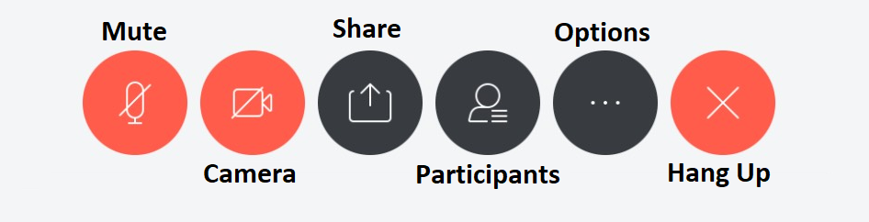

1. **Mute on/off.** Grey indicates your microphone is unmuted, red is muted. This setting may be controlled by the meeting host*. Keep yourself muted until you need to speak or are called on.*

2. **Camera.**  Blue means camera on Red means camera is off. Where possible turn on your camera. Camera use is not required, and may reduce audio quality on poor internet connections.

3. **Share.** Light grey indicates you do not have permissions to share your screen or any other content with the meeting. This is granted by the host or the current presenter can pass off sharing.

4. **Participant panel.** Toggles on and off the participant panel. Blue is on, grey is off. This must be turned on (blue) to use Raise Hand and Feedback.

5. **Chat** (messages). Chat is disabled. If Chat is available, ALL chat log data is public record including private chats.

6. **Options**. Includes changing microphone and camera settings. When setting up the first time you may need to change your audio, or video device using this button.

7. **Hang up.** This will disconnect you from the meeting.

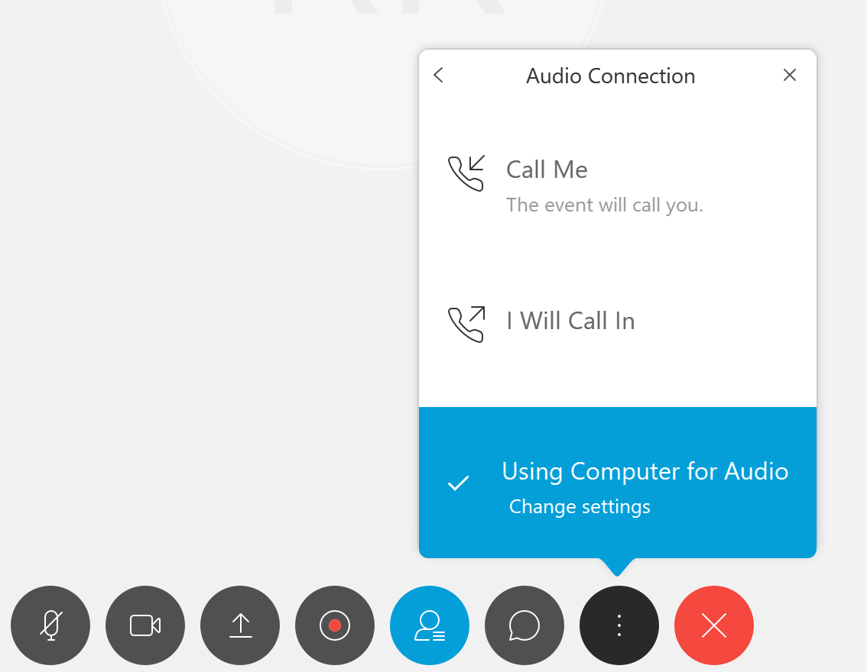Calling In

When you call in you have 3 options.

1. **Call Me.** You enter a phone number and the system will call it.
2. **I will Call In.** You manually call in using the, meeting code and participant ID.
3. **Using Computer for Audio.** Requires that you have a microphone and speakers. Default option.

Raise Hand

During the meeting you will have the option to signal to the meeting using the raise hand button found in the Participants panel. (Note, the Feedback button will not be used at this time.)

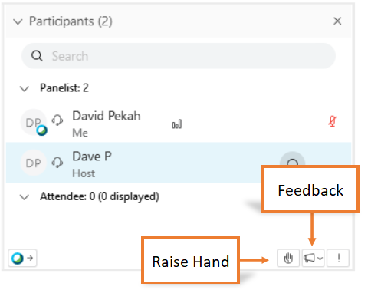



When the Raise Hand button is activated the Raised Hand icon will appear next to the Panelist’s name. Clicking the button again will remove the hand icon. The Host can clear all hand icons if needed.

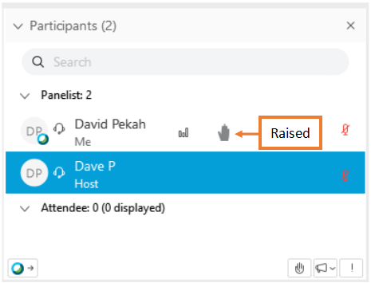

## Cisco Help

* [Join a Cisco Webex Event](https://help.webex.com/en-us/kwmj5eb/)
* [Choose Your Audio and Video Settings Before You Join a Webex Meeting or Event](https://help.webex.com/en-us/nt2ig0y/)
* [Audio Broadcast in Cisco Webex Events](https://help.webex.com/en-us/ilxl5eb/)
* [Mute or Unmute in Cisco Webex Meetings Suite](https://help.webex.com/en-us/n94aj5j/)
* [Webex Audio Support](https://help.webex.com/en-us/nc66g2h/)
* [Use Webex Audio in Webex Events](https://help.webex.com/en-us/nm3r8v9/)
* [Start or Stop Your Video During a Cisco Webex Event](https://help.webex.com/en-us/neia5sk/)