WebEx Basics **1. Do I need a WebEx account?**   
a. You only need a WebEx account if you are a HOST. The HOST is the presenter or the person who conducts the meeting and sends invitations.   
  
A participant does not need to have a WebEx account; participants are able to join a meeting without an account. If you do not send invitations to a meeting or lead the meeting, this information is not necessary to you.   
  
If you are new to WebEx and would like to become a HOST for audio and video conferencing, please obtain your supervisor's approval and then contact the Help Desk; they will create a new WebEx account for you.   
  
**2. How do I login to the new WebEx?**   
a. Go to <https://racinecounty.webex.com> and at the top right corner, you will see a sign in button. Enter your email address and the login password you created. (Do not select Office 365)  
  
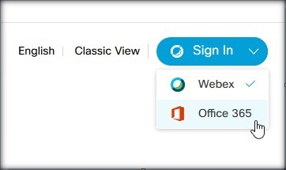  
  
  
**3. Is my account active?**   
a. If you have ever used WebEx before we have imported your account into the new system. After you login you should see a verification email request. Click send – and you will get an email to activate your account. After this is completed, if you try to login again you should be good to go.   
  
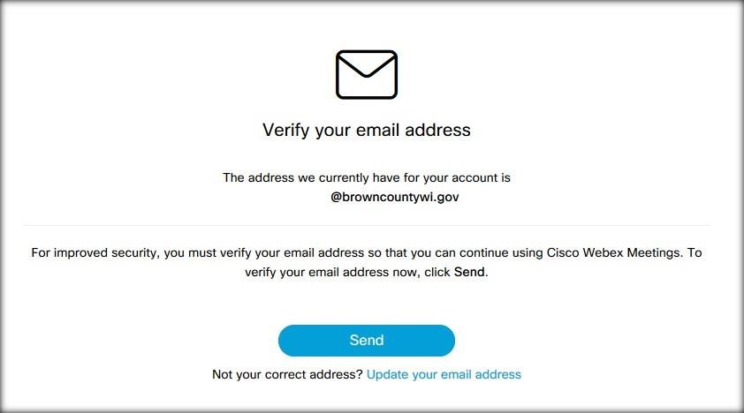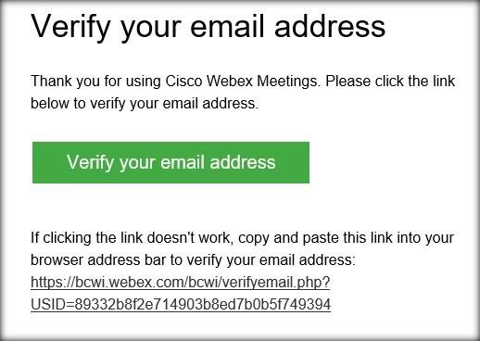  
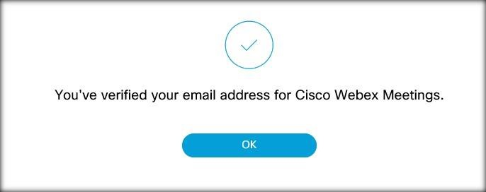  
  
  
  
  
  
  
  
  
  
**4. What if my account isn’t active or I need to setup a WebEx account?**   
a. Please call extension 4030 or submit a work order ticket to gain access. You will need to follow the steps above. If you are new, you will need to get your supervisor’s approval for WebEx.   
  
**5. What happens to reoccurring meeting entries that I used for WebEx?**   
a. Since the system has moved to the cloud, we were not able to migrate those future meetings. So please recreate new invites for future WebEx meetings.   
  
**6. What happens to my old Cisco WebEx Meet Now tool in Outlook?**   
a. Your old tool will work until the old server is turned off. The server will be turned off Wednesday (12/4). A new tool will need to be installed since the old application is looking at the old on-premise server. The new tool will be installed during Wednesday night's patch process.   
  
**7. How do I log into the new tool?**   
a. To log into the new tool you must first login from <https://racinecounty.webex.com>.  On your home page click "Start A Meeting", it should ask to download the tool.  Once it has finished running the install process, it will launch the application. This will start a meeting and you can simply close the program. You can then launch the program from your desktop shortcut or from the Start menu. The program will do a Single Sign On - and you will not need to put in your credentials. Your Outlook tool will also be logged in.   
  
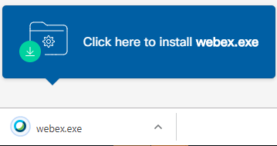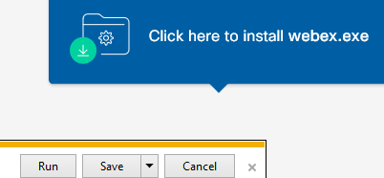  
  
  
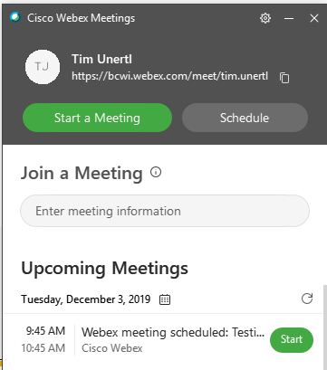  
  
**8. Will Cisco WebEx work from a mobile device?**   
a. Yes, it will. Visit your device's App Store and download the Cisco WebEx Meetings app.  Launch the app, sign in, select Microsoft (the site is racinecounty.webex.com) and provide your email and password if asked.