
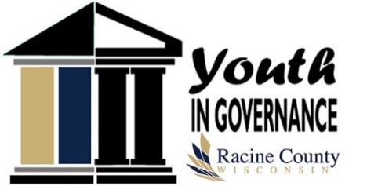
Youth in Governance

Group Project Meeting

Dennis Kornwolf Service Center

2 South Conference Room
1717 Taylor Avenue

Monday, January 13, 2020
6:00 P.M.

This Location Is Handicap Accessible. If You Have Other Special Needs, Please Contact The Racine County Clerk, 730 Wisconsin Avenue, Racine, Wisconsin 53403, (262) 636-3121 Or The TTD/Relay Service 1-800-947-3529

- Welcome and Introductions
- Committee Updates
- Tour & Group Projects Planning
- Wrap-up: Determine roles and responsibilities for next meeting
- Set next meeting date

Racine County Youth in Governance is a program of Racine County Board of Supervisors in partnership with Racine County UW-Extension.

An EEO/AA employer, University of Wisconsin-Madison, Division of Extension provides equal opportunities in employment and programming, including Title VI, Title IX and ADA requirements.

