   
**Friday, November 2, 2018**

**WIS 38 & County MM**

**Project Update**

**November 2, 2018**

MM Section

1. Complete removing pavement. Continue to process pavement for subbase.
2. Excavate soil from south end to Rivershore Drive.
3. Place subbase material.

(All Traffic on CTH MM will remain on the east side of the roadway from River Shore Drive to the South end.)

STH 38 and MM Section

1. Finish setting grades.
2. Start curb and gutter late in the day and finish on Saturday.

**Saturday, November 3, 2018**

MM Section

1. Excavate soil from South end to Rivershore Drive
2. Place Subbase Material

(Work will end mid-day)

(All Traffic on CTH MM will remain on the east side of the roadway from River Shore Drive to the south end.)

STH 38 and Mill Rd. Section

1. Install Curb and Gutter

**Sunday, November 4, 2018**

NO WORK

(All Traffic on CTH MM will remain on the east side of the roadway from River Shore Drive to the south End.)

**Monday, November 5, 2018**

MM Section

1. Excavate soil from the south end to Rivershore.
2. Place Subgrade Material.
3. Begin Trucking in and placing offsite base.

(All Traffic on CTH MM will remain on the east side of the roadway from River Shore Drive to the South End.)

STH 38 and Mill Rd. Intersection

1. Prep or pour concrete.

**Tuesday, November 6, 2018**

MM Section

1. Excavate Soil from the South end to Rivershore.
2. Place Subgrade Material.
3. Truck in and place base.

STH 38 and Mill Rd Intersection

1. Prep and Pour Concrete

**Wednesday, November 7, 2018**

MM Section

1. Excavate Soil from South end to Rivershore.
2. Place Subgrade material.
3. Truck in and place Base.

STH 38 and Mill Rd Intersection

1. Prep and Pour Concrete

**Thursday, November 8, 2018**

MM Section

1. Excavate Soil from South end to Rivershore.
2. Place Subgrade material.
3. Truck in and place base.

STH 38 and Mill Rd. Intersection.

1. Prep and Pour Concrete.

# Extended Weather forecast:

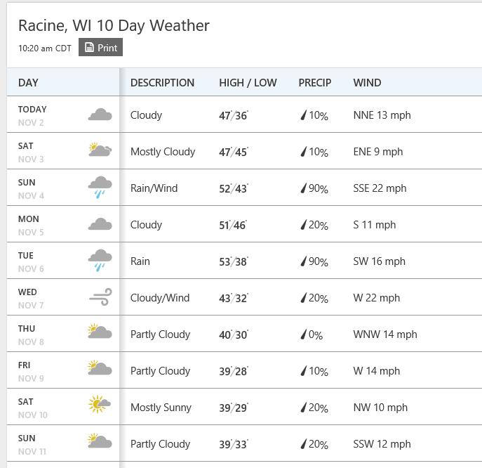

Project contact:

**Josh Skarsten, PE**

D 414-944-6199  
[josh.skarsten@aecom.com](mailto:josh.skarsten@aecom.com)