**Procedure Title:** Contract or Open PO on Pcard

**Purpose:** Attach a contract or Open PO to an applicable pcard transaction

**Due Date:** when needed

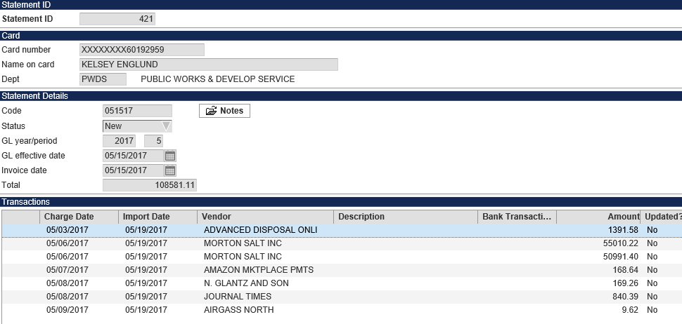

In the Purchase Card Statements program, search for the pcard statement.

Double click on the transaction needing a PO or click Transactions and navigate to the transaction.

Click update and enter all of transaction information. Be sure to make the vendor number match the contract/open PO’s vendor number (if it doesn’t already). Update the charge description, invoice number if applicable, and account numbers.

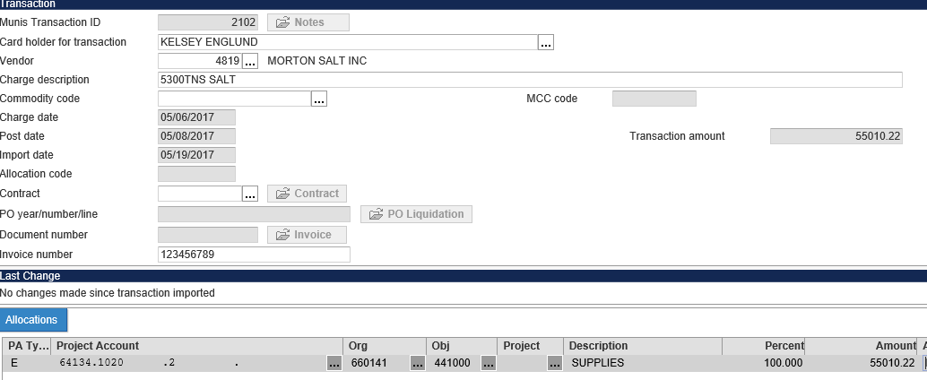

Click on the field edit folder next to Contract.



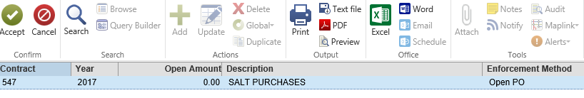

All applicable contracts/open PO’s for this vendor will appear. Be sure to select the correct contract as a vendor could have more than one contract. Select the contract and press Accept.



The contract is now attached to the pcard. Tab down into the account number section to allow the system to check budget. If there is adequate budget, click Accept to save your transaction.

**Issues that may come up:**

1. Wrong account number – for regular contracts (not open PO’s) you may only use an account number that was originally entered on the contract. You must either change the pcard transaction account number or initiate a contract change order to change the account number on the contract.
   1. Example: Contract was entered for contracted services. The pcard charge is going to temporary help. Change the account number contracted services and press Accept.
      1. If the contract was incorrectly entered with the wrong contract, the account needs to be changed or a new account added, a change order must be done.
2. Not enough budget on contract – regular contracts have a set dollar amount allocated. If this pcard transaction will make the contract go over the allocated budget, it will not allow posting. Initiate a contract change order.
3. Not enough budget on account – open PO’s do not encumber funds but the system will keep track of budget per account line item. If there is not enough money on the budget, an error warning will appear. As of 5/26/17, we do not stop payments for lack of budget availability. Click ok through the error to complete.
4. No contract/open PO is found – make sure the vendor number matches the vendor number on the contract or open PO exactly. During import, pcard transactions may not identify existing vendors in the Munis system. When in update mode, change the vendor number to match the contract.