How to Approve and Post a Journal Entry

Munis Version 11.3

On the Dashboard, click on Approvals

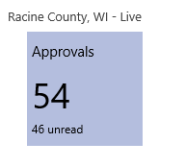

All waiting approvals will appear

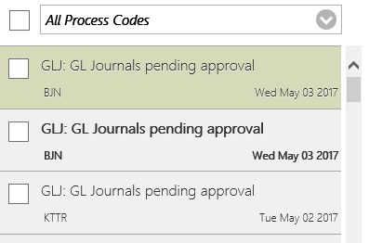

Click on the entry for approval. A summary of the entry will appear in the right column. Click on the blue hyperlink to go to the Accounting Entries program.

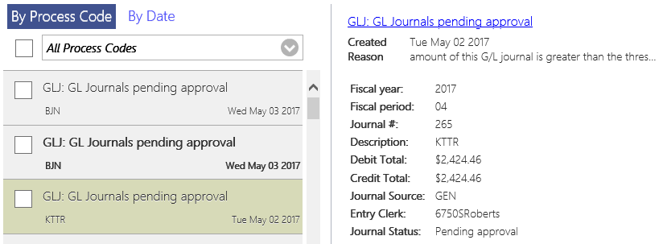

A summary of the entry will appear. Open the Attachments to view the scanned image.

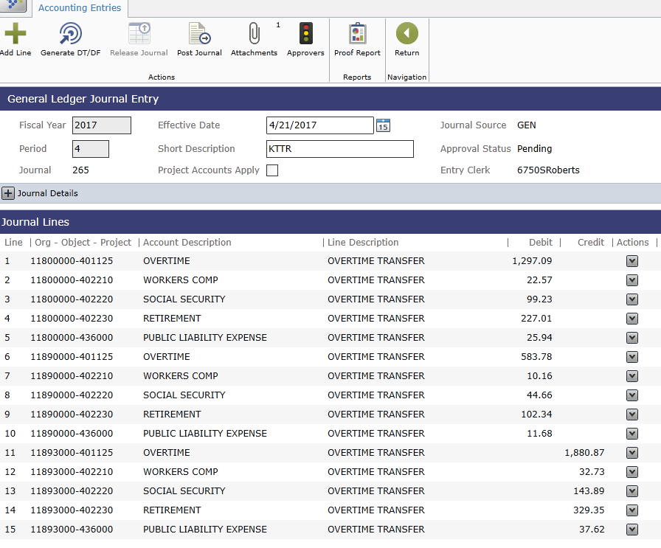

After reviewing the scanned image, appropriateness of account numbers, and dollar amount, click Approvers   


All of the approvers on this step will appear and your name will be highlighted as the user taking action.

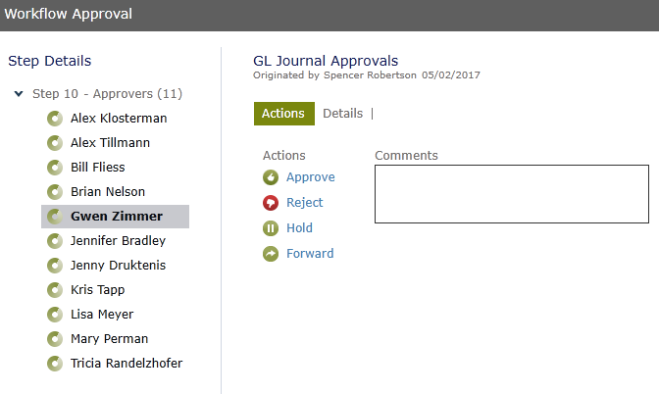

Either Approve, Reject, Hold, or Forward the entry and click Save.

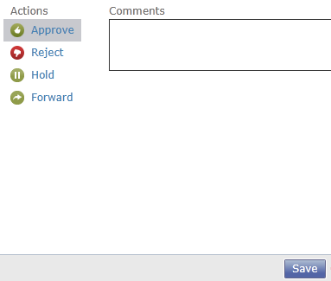

The program will update the journal entry and move back to the Accounting Entries screen. The status will change from Pending to Approved.

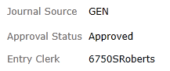

Once the entry is approved, click Post Journal



If no errors are found, click Ok.

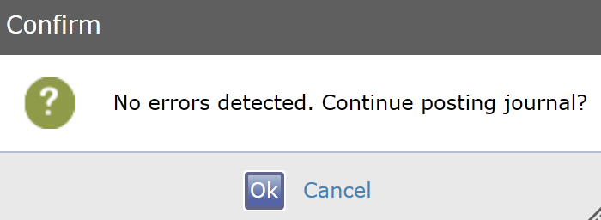

After the journal is approved, click Ok.

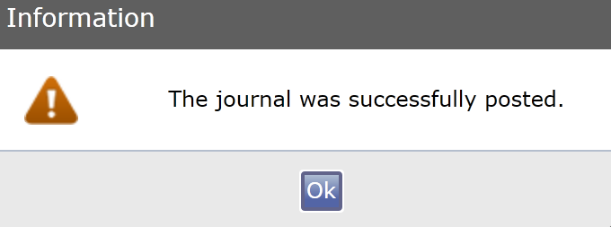

The program will go back to the main Accounting Entry screen. From there, you can find the next entry that needs to be approved or close the Accounting Entry tab to return to the main Dashboard.

If there are problems posting the entry, it’s probably because it’s unbalanced because of due to/due from. Munis will not allow an unbalanced entry or inactive account number to be submitted into workflow. The due to/due from can make the entry off by a penny or two. To fix this, it will need to be updated in the General Journal Entry/Proof program by the originator of the entry.