## Register for Tylertech.com

* + - 1. Navigate to [www.tylertech.com](http://www.tylertech.com)
      2. Click **Register**

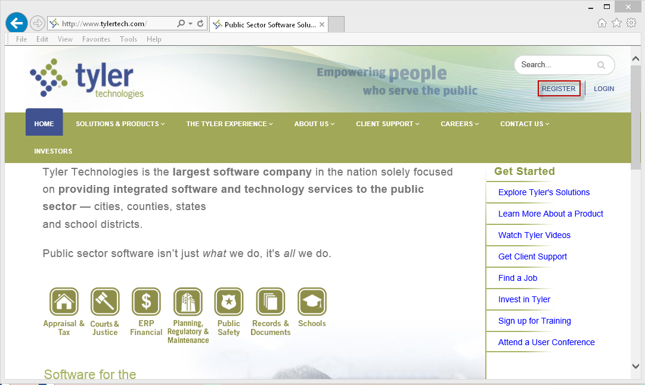

* + - 1. Select **Munis**
      2. 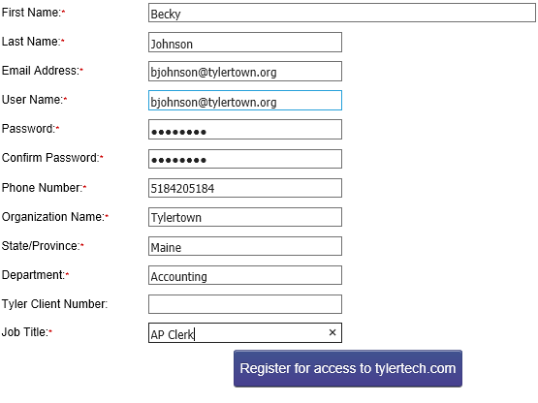Complete the registration form:

|  |
| --- |
| **First Name** – required |
| **Last Name** – required |
| **Email Address** – please enter your work email address - required |
| **Username** – please use your email address for your username - required |
| **Password** – required |
| **Confirm password** – required |
| **Organization Name** – required |
| **State/Pro**vince – required |
| **Department** – required |
| **Tyler Client Number** – not required |
| **Job Title** – required |

* + - 1. Click **Register for access to tylertech.com**

Please note: It can take up to 24 hours to receive confirmation that registration is complete

* + - 1. Log in to: <http://www.tylertech.com/client-support/tyleru-login>