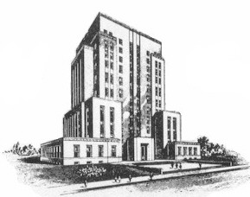
RACINE COUNTY
Office of the Racine County Treasurer
JANE F. NIKOLAI

730 Wisconsin Avenue
Racine, WI 53403
(262) 636-3239

Date_______________________

AFFIDAVIT OF OWNERSHIP OF UNCLAIMED FUNDS
ACCOUNT # 780.211130 (Muni’s, odd years)

Year Published: 2017 Amount $______________________

CLAIMANT #1 CLAIMANT #2 (if needed)

______________________________ _______________________________
Name (Please Print) Name (Please Print)

______________________________ _______________________________
Mailing Address Mailing Address

______________________________ _______________________________
City, State, Zip City, State, Zip

______________________________ _______________________________
Telephone Number Telephone Number

I do hereby swear that I am the lawful owner(s) of this money and am lawfully entitled to
claim it from Racine County.
Signature(s) - Sign in front of County Treasurer’s Office Witness or Notary Public

X_______________________________ X_______________________________
Claimant’s Signature Claimant’s Signature

-------------------------------------------------------------------------------------------------------------------------------------------------------------------------------

To Be Completed by County Treasurer’s Office: To Be Completed by Notary:

Proof of Identity: State of _________________________
County of ________________________
#1_____________________________________ This instrument was acknowledged and
Sworn before me on _______________
By ______________________________
#2_____________________________________
_________________________________
Signature of Notary Public
Notary Public
_______________________________________ My Commission Expires ______________
Receipt Acknowledged by

(Seal)

