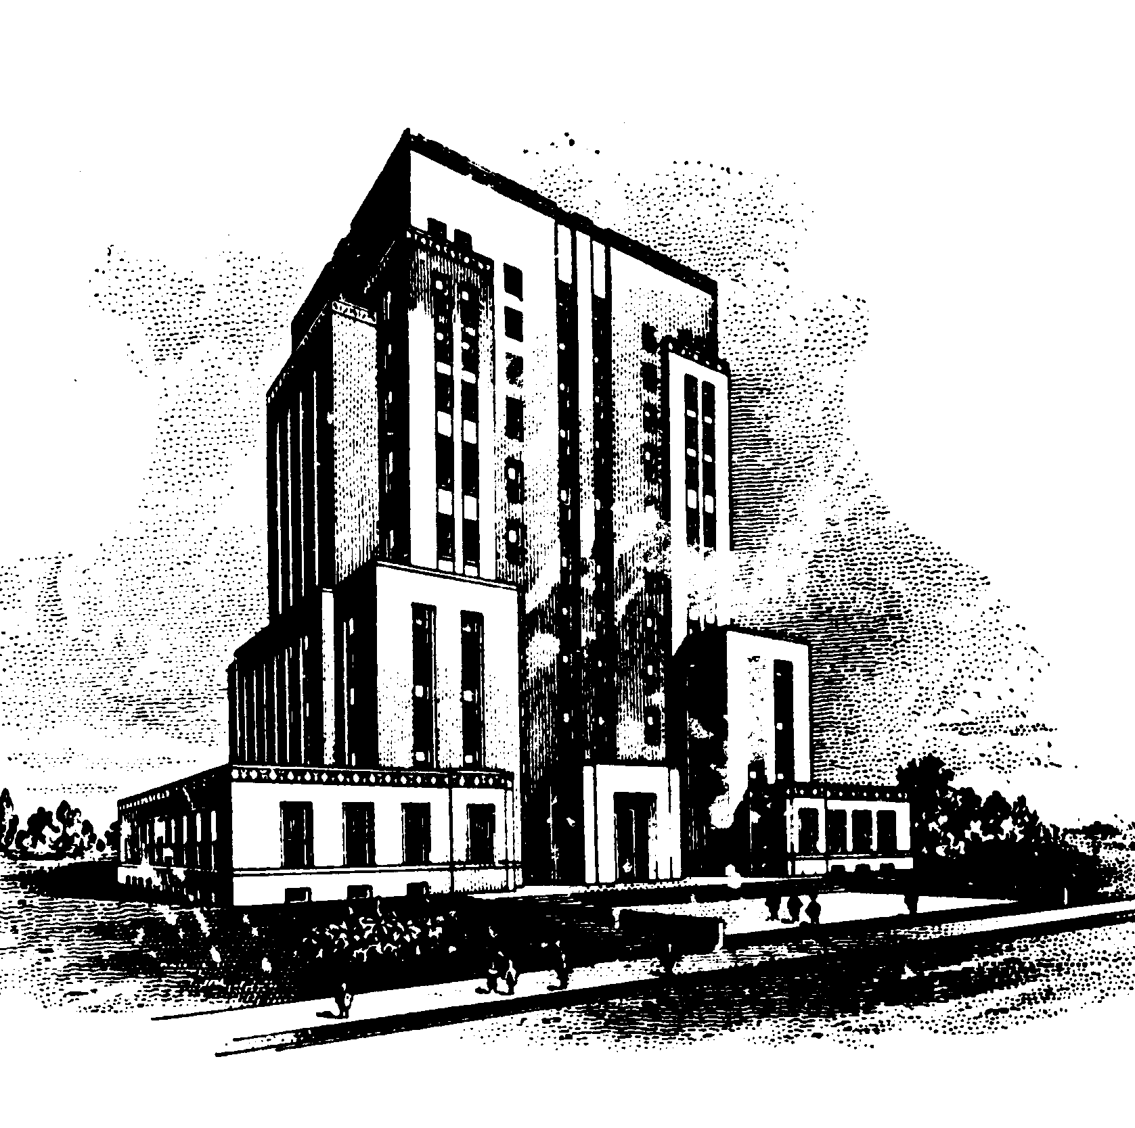
Racine County
Human Services Department

Racine County Dennis Kornwolf Service Center
1717 Taylor Avenue
Racine, WI 53403

ADDENDUM A

Request for Proposal

JUVENILE MONITORING PROGRAM
Bid #500

This Addendum has been prepared by: Mary Perman
Date: September 20, 2016

The following questions were forwarded to Racine County from an interested vendor. Racine County’s response immediately follows the question submitted.

- “I can’t seem to determine how many staff and staffing hours are required in order to put together a bid.”

Response: There are two (2) FTE staff associated with this program.

- “I am unable to determine the number of your involved.”

Response: Each staff person is allowed to have a maximum of 20 juveniles on their caseload at any given time. In 2015, 195 juveniles were served by this program.

- “I also am not clear…does the County expect families to be invoiced for the services directly from the Provider? What happens if families do not pay?”

Response: It is the responsibility of the vendor to collect all dues from the families.

Please sign, date and attach a copy of this addendum to your Proposal.

Firm: ______________________________________________________________________

Signature: __________________________________________________________________

Date: ______________________________________________________________________

